Choose the letter of the correct answer. In all cases, NOTA means “none of these answers”.

1) If Sophie will not sleep, then Sophie will see a giant. Find the contrapositive of the inverse of the converse of this statement.
A) If Sophie does not see a giant, then Sophie will sleep.
B) If Sophie sees a giant, then Sophie will not sleep.
C) If Sophie will not sleep, then Sophie will see a giant.
D) If Sophie will sleep, then Sophie will not see a giant.
E) NOTA

2) Sophie sees a giant from her bedroom window. If the 24 feet tall giant is standing in front of the street light, and casts a 18 feet shadow, what is the distance, in feet, from the top of his head to the end of the shadow?
A) 5 B) 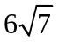 C) 30 D) 42 E) NOTA

3) The giant has snatched Sophie from her bed, and takes off! Sophie is trapped inside her rhombus-shaped blanket, with the diagonals of the blanket being 10 feet and 5 feet. What is the area of Sophie's blanket in square feet?
A) 100 B) 50 C) 42 D) 25 E) NOTA

4) The giant continues running, until he reaches a mountain. Rolling aside a stone, the giant lowers Sophie into a corner of the rectangular prism shaped cave. Once the giant turns the lights on, Sophie sees rows and rows of jars. If the cave is 8 miles by 6 miles by 2 miles, what is the length, in miles, of the furthest distance a jar could be from Sophie, assuming the jars can be stacked?
A) 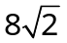 B) 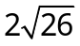 C) 10 D) 8 E) NOTA

5) If the statement: “If the giant is friendly, then he will not eat Sophie” is true, then which of the following statement(s) are also definitely true?
i. If the giant does not eat Sophie, then he is friendly.
ii. If the giant eats Sophie, then he is not friendly.
iii. If the giant isn't friendly, then he will eat Sophie.

A) only statements i & iii B) only statement ii
C) statements i, ii, & iii D) only statements i & ii E) NOTA

6) The BFG has warned Sophie not to wander outside of the cave, or else she might run into the Bonecruncher located at point B(10, 12) . If Sophie is located at point S(6, 15), what is the equation of the line perpendicular to line BS at point S?
A) 4x-3y = 21 B) 4x-3y = -6 C) –x+3y = 6 D) 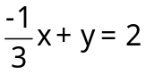 E) NOTA

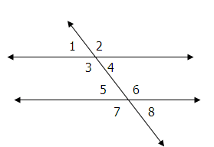
7) Sophie has just learned that the BFG is a dream-blowing giant. The night that she was kidnapped, the BFG was blowing dreams on a street that intersected two parallel streets. If the measure of angle 1= (x - 2) and the measure of angle 3 = (5x - 16), then find the measure of angle 8.
A) 31 B) 149 C) 33 D) 147 E) NOTA

8) The BFG also delivered good dreams to children on a street that follows a regular hexagonal path. If the radius of the hexagon is 60 meters, and he could only make it 2/3 of the way along the street before the sun came up and he had to return to Giant County, how many meters did he run?
A) 180 B) 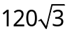 C) 240 D) 360 E) NOTA

9) The BFG is able to catch dreams because of his amazing ears. (Because dreams make tiny little buzzing-humming noises, of course!) If the BFG's ears are in the shape of a triangle, which of the following number triples can represent the lengths of the sides of his ear?
i. 16, 8, 8
ii. 7, 16, 10
iii. 9, 40, 41
iv. 564, 232, 332
A) i, ii, & iii only B) ii &iii only C) iii & iv only
D) i & iv only E) NOTA

10) Because the BFG does not eat humans, he has to eat disgusterous, rotsome, maggotwise snozzcumbers. He cuts a small sliver (of negligible thickness) in the shape of a regular octagon for Sophie to taste. If each side of the snozzcumber is 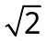 inches long, find the area of the slice.
- 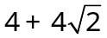 B) 14 C) 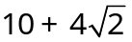 D) 16 E) NOTA

11) The Bloodbottler has heard the BFG talking to Sophie! He is very hungry and wants a tasty human bean snack, so he starts searching for her. If he walks 3 meters due north, 6 meters due west, 8 meters due south, 2 meters due north, and then 2 due meters east, how many meters is he from his starting point?
A) B) 10 C) 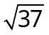 D) 5 E) NOTA

12) The BFG is going to take Sophie to Dream Country, to show her how to catch dreams! The distance he travels is equal to the geometric mean of 18 and 2, plus the arithmetic mean of 10 and 12. What is the total distance, that he will travel (disregarding units)?
A) 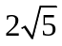 B) 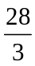 C) 17 D) 21 E) NOTA

13) Once they reach Dream Country, the BFG catches a golden phizzwizard! (These are the best kinds of dreams!) In fact, this particular one gives children dreams about geometry! Given triangle ABC with BC = 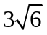, and angle A = 60 and angle B = 75, what is the length of side AB?
- 3 B) 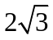 C) 6 D) 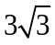 E) NOTA
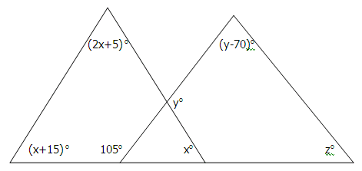
14) Oh no! Mince my maggots! Oh swipe my swoggles! The BFG has caught a trogglehumper! It is the worst kind of nightmare of all! Not only that, but it is also a bogthumper and a grobswitcher, all riddled in one! Given that it is shaped like the figure to the right, what is x + y + z?

A) 40 B) 60 C) 115 D) 225 E) NOTA

15) On their way back home, the BFG suddenly has a brilliant idea, and gives the Fleshlumpeater the trogglehumper! The Fleshlumpeater starts dreaming about famous giant-killer Jack, and his giant-killing beanstalk. Jack asks giants this question, “What point of concurrency is where the perpendicular bisectors of a triangle intersect?” and if the Fleshlumpeater gets it wrong, then he will be killed. What is the answer?

A) Orthocenter B) Centroid C) Circumcenter D) Incenter E) NOTA

16) Back in his home, the BFG shows Sophie his jars of dreams. On each jar, he writes a label to remind him what each dream is about. Sophie reads one that says “I is only an eight year old little boy but is growing a splendid bushy beard and all the other boys is jalous” If the boy's beard grows to be an equilateral triangle with an area of 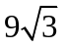, what is the perimeter of the triangle?
A) 6 B) 9 C) 12 D) 18 E) NOTA

17) The other giants are off to England to eat tasty school children by the bundles! Sophie and the BFG are trying to think of a plan to save the children. They are sitting on a giant spherical blue rock, with a volume of 972. What is its circumference?
A) 972 B) 18 C) 9 D) 3 E) NOTA

18) By golly! Sophie has a plan! If they can get the Queen of England to dream about the giants, then she can send troops to go capture them! However, to make this, they need a dream in the shape of a sphere, inscribed in a cube with length 10. What is one half the volume of the sphere in terms of pi?
A) 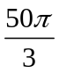 B) 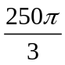 C) 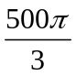 D) 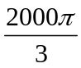 E) NOTA

19) The BFG is mixing up the dream for the queen in his potion holder, which is in the shape of a cone, and fills it up to a height of 14 and radius 6. However, to complete the potion, a sphere of radius 3 must be dropped inside the potion. Assuming the potion does not overflow, what is the total volume of a completed potion in the potion holder, including the sphere?
A) 36 B) 132 C) 168 D) 204 E) NOTA

20) The BFG puts the resulting nightmare into his pockets. Sophie doesn't want to sit with the nightmare, so she asks to sit in the BFG's ear instead. We assume again, that his ear is a triangle, BFG. The length of side BF = 4, FG = 6, and BG = 8. What is the area of his ear (disregarding units)?
A) 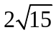 B) 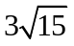 C) 24 D) 12 E) NOTA

21) The BFG and Sophie have finally reached the palace, which is shaped as a regular decagon. If the sum of the palace's interior angles equals A, and the perimeter of the palace = B, given that the length of a side is 6 units long. Find A+B.
A) 1380 B) 1440 C) 1500 D) 1860 E) NOTA

22) Upon finding the queen, the BFG has to blow her the nightmare with his trumpet. The Queen's head is a circle S, and the BFG's trumpet is a quadrilateral BFSG. Circle S has tangents BF and BG with angle B = 60, and point F and G on the circle. If the radius of the circle is 8, what is the area of BFSG?
A) 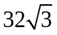 B) 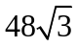 C) 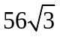 D) 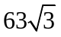 E) NOTA

23) The BFG is waiting for Sophie in the garden of Buckingham Palace, which is in the shape of a rhombus. If the four edges of the garden are each 15 feet in length, and the one of the garden's diagonals is 18 feet across, what is the area, in square feet, of the garden that the BFG can wait in?
A) 324 B) 216 C) 108 D) 54 E) NOTA

24) Mr. Tibbs, the butler, must construct a triangular table big enough to fit the BFG. He needs to inscribe a big circular plate inside it and wants to figure out where to put the center. The intersection of which of the following lines in a triangle is also the center of the triangle’s inscribed circle?
A) Perpendicular Bisectors B) Medians C) Altitudes
D) Angle Bisectors E) NOTA
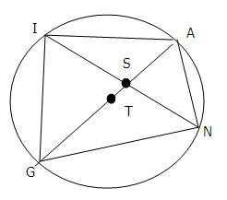
25) The BFG eats his breakfast out of a very special plate, illustrated at the right. Given that circle T has a radius of 8, angle AGN = 30°, GS:SA = 3:1, and IS:SN = 3:4, find the area of TSN.
T
A) B) 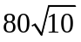 C) 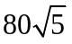
D) not enough information E) NOTA

26) After breakfast, the queen calls the head of the army and the head of the air force. Together, with the help of the BFG, they decide to go capture the giants while they are asleep and bring them back tied to helicopters. Given that one helicopter is at M(0, 0), another at A (3, 4), and another at Θ (0, 4), what is the area of triangle MAΘ?
A) 3 B) 6 C) 8 D) 16 E) NOTA

27) The helicopters are dropping the giants into a giant hemispherical hole, with radius r. If the radius of the hole is increased by 4, how many times larger is the area of the new hole?
A) 4 B) 16 C) 32 D) 64 E) NOTA

28) The BFG ties Fleshlumpeater to the outside corner of a square rock that is 15 feet on each side, using a rope that is 20 feet long. Assuming that the man guzzling giant does not break the rope and cannot break into the rock, what is the total number of square feet over which he can walk?
A) 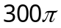 B) 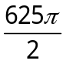 C) 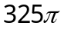 D) 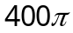 E) NOTA

29) After the mean giants were imprisoned, the BFG became a hero, and expressed a wish to learn geometry properly. Help him find the measure of arc ABP on circle O, if two circles with centers O and P are positioned such that point O lies on circle P and point P lies on circle O, and the circles intersect at A and B.
A) 60 B) 90 C) 120 D) 135 E) NOTA

30) Eventually, the BFG became so good at geometry that he wrote a test. The Queen gave the test to her grandchildren, and arranged for it to be published. But because the BFG is a very modest giant, the test is published under a different name. Where, you might ask, is this test the BFG wrote? It's right here. You just finished taking it. (The answer is A)
A) A B) B C) C D) D E) NOTA

